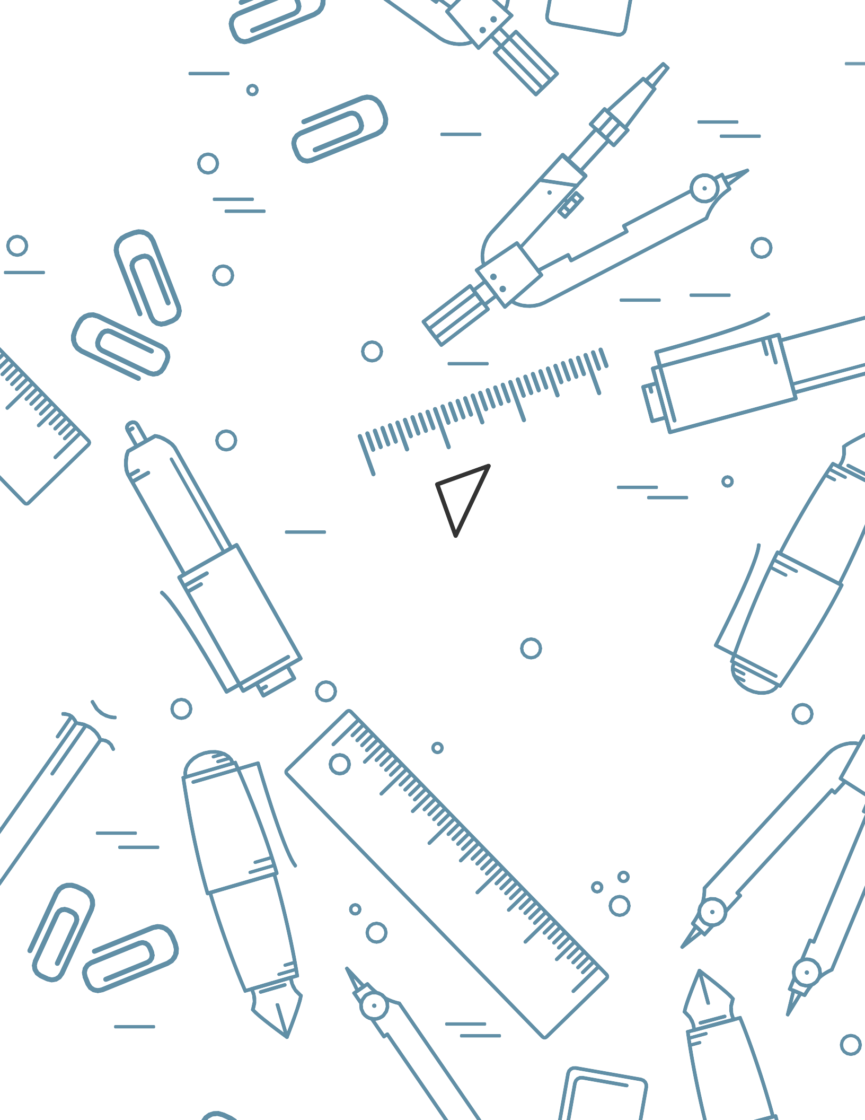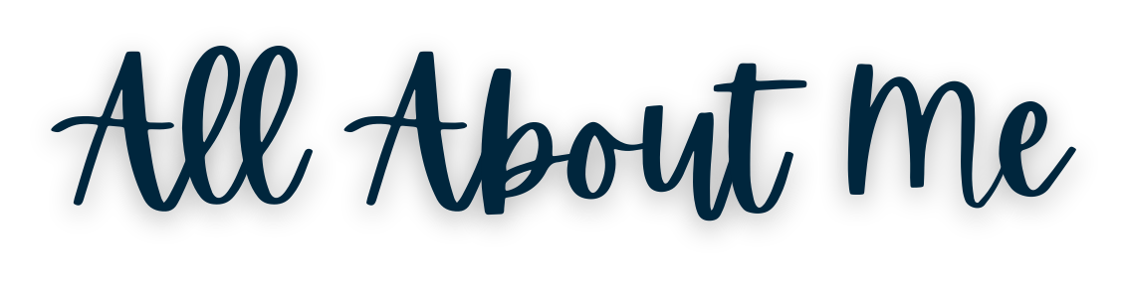About Me

My Strengths/Things I'm Good At:

I Have Difficulty With: I Learn Best When:

If I Get Upset, You Can Help Me By:

My Diagnosis/Medications/Allergies:

